Platforms: Instagram and Twitter are two social media platforms Cal U uses.
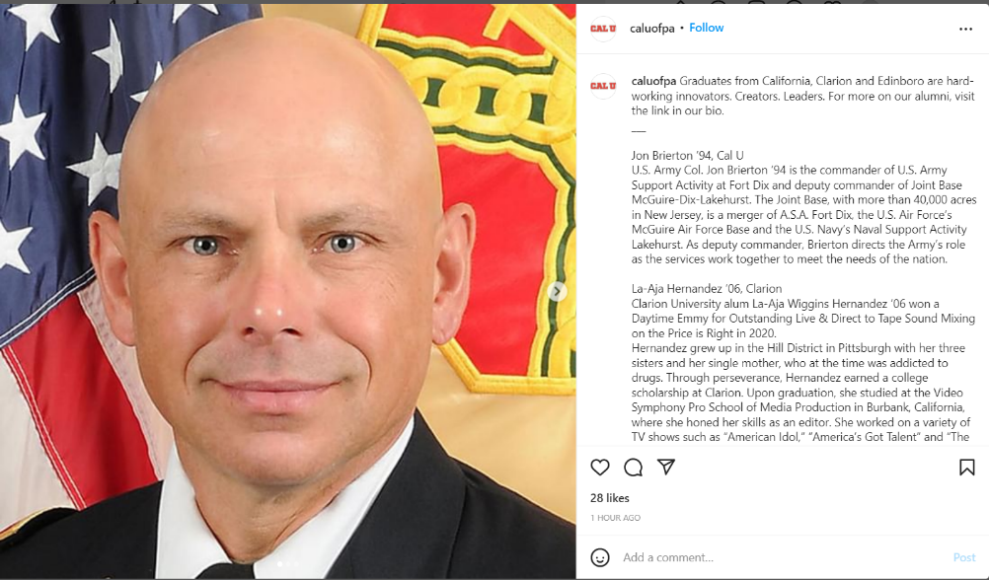
Instagram:

Instagram is used here to show some of the accomplishments of Cal U graduates.

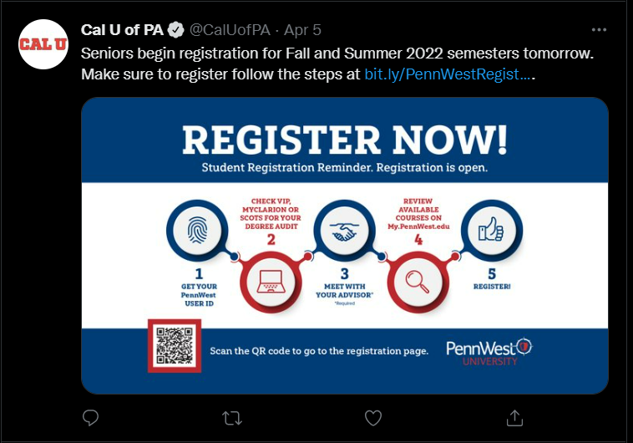
Twitter:

Twitter is used primarily for announcements and to advertise upcoming events. Instagram does this too, but Twitter seems to focus on it more.

Social media policy:
- Cal U has the right to remove any abusive, unlawful, copyright infringing, advertising, or spam comments from their platforms.
- Anyone who posts such comments might also get banned from commenting again.
- Cal U may use anything posted to their platforms as they see fit, without the consent of the original poster.
- Posted material only represents the opinion of Cal U if it was approved or authorized by a Cal U official.

The First Amendment:
The first amendment protects our freedom of speech. It does not mean that the social media sites of Cal U, or any other social media site, should be required to provide us a platform. The owner or moderator of the platform gets to choose what they want to share with the world, and that might not be the same thing that we want to share. This is fine, because if we want to share something, we can do it on our own platform. We are not entitled to their audience.

